Chi Minh I primary school
Name: ………………………………  Class:………….. | THE FIRST SEMESTER TEST  ENGLISH - CLASS 4  School year : 2022 - 2023  Time: 35 minutes

Skill | Listening | Reading | Writing | Speaking | Total
Mark

LISTENING
PART 1: Questions 1-4: Listen and number. (1pt)
A | B | C | D



PART 2: Questions 1-4: Listen and tick the box.(1pt)

1.
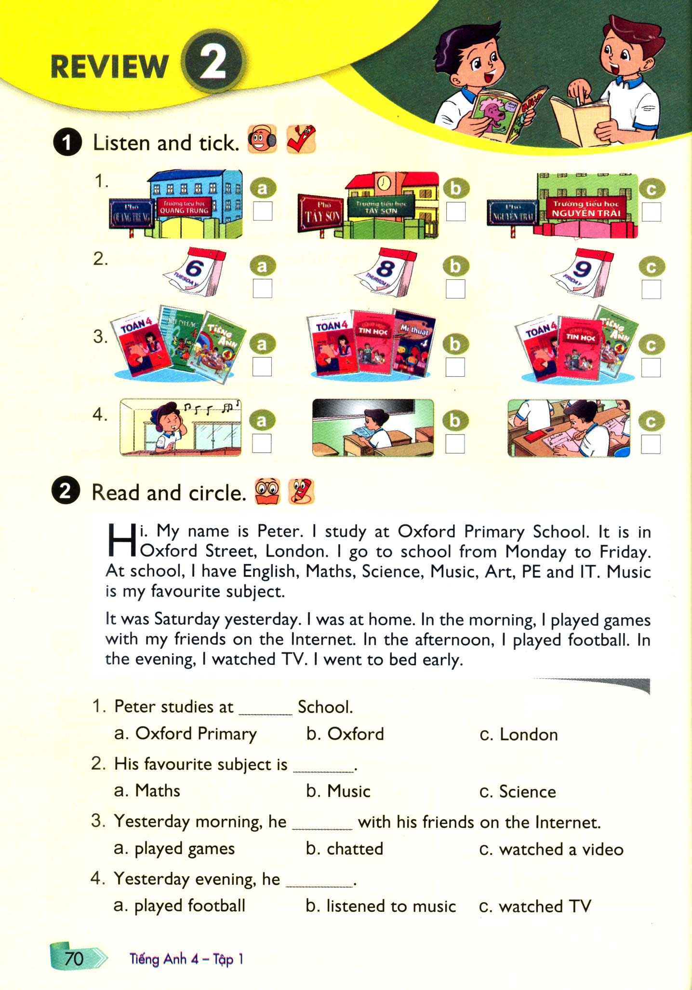

2.

3.

4.
READING
PART 1: Questions 1-4. Read and circle the correct answers.( 1pt)There is one example (0).
Hi. My name is Peter. I study at Oxford Primary School. It is in Oxford Street, London. I go to school from Monday to Friday. At school, I have English, Maths, Science, Music, Art , PE and IT. Music is my favourite subject. It was Saturday yesterday. I was at home. In the morning, I played games with my friends on the Internet. In the afternoon, I played football. In the evening, I watched TV. I went to bed early.
Example (0). Peter is from ___________
B
A. Australian London C. Malaysia
1. Peter studies at ____ school.
- Oxford Primary B. Paris C. London
2.His favourite subject is ____________ .
- Maths B. Music C. Science
3.Yesterday morning , he ____________ with his friends on the Internet.
- played games B. chatted C. watched a video
4. Yesterday evening , he _____________.
- played football B. listened to Music C. watched TV

PART 2. Questions 5-8. Match the words with pictures. (1pt)
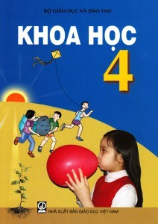 | 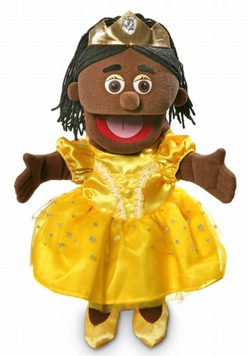 | 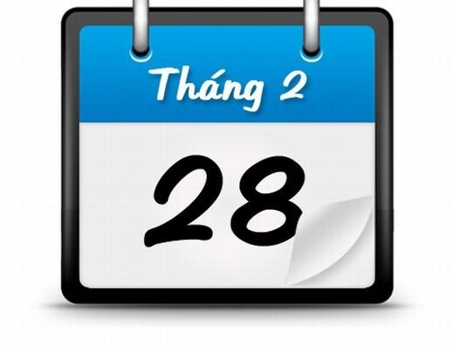 | 
A | B | C | D
5. Science | 6. February | 7. puppet | 8. Japan

PART 3. Questions 9 -12.Read and fill the gaps with the correct words (1pt).

happy | England | friend | Music club
This is my new (9) …………… Her name is Linda. She is from (10) …………………… She can sing many Vietnamese songs. In her free time, she goes to the (11) ………………. She is (12)………. ……. there.

WRITING
PART 1 Questions 1- 3: Look at the pictures and the letters. Write the words.(1pt)

 |  | 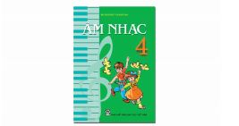 | 
1.ookc | 2. isng  _____________ | 3.sicmu  _______________ | 4. kips  _____________

PART 2 :Questions 5 – 8. Reorder the words to make the sentences. There is an example. (1pt) (0) is / Monday / today/./ -> Today is Monday.
5.you/ doing?/ do/ like / What /
___________________________________________
6.are/ Where/ from?/ you
____________________________________________
7. swim. / I / can
____________________________________________
8.class 4C./ I’m / in

_____________________________________________

PART 3:Questions 8 – 10. Write the correct word for each gap. (1 pts)

District | Viet Nam | subject | watching a video

Hello. My name is Van. I am from (9) ………… . I’m Vietnamese. I am a student at Nguyen Hue Primary School. It’s in Hoan Kiem (10) …………. . I can cook but I can’t dance. I like (11)…………… , but I don’t like playing football. Today is the ninth of December. I have English. I have it on Tuesdays and Wednesdays. It is my favourite (12)………………..

**********************************

ĐÁP ÁN VÀ BIỂU ĐIỂM BÀI KIỂM TRA HKI
MÔN TIẾNG ANH LỚP 4 – NĂM HỌC 2021-2022

LISTENING
PART 1: Question 1-4. Listen and number(0,25*4 =1pt)
1.B 2.D 3.A 4. C
PART 2 :Question 1-4. Listen and tick the box(0,25*4 =1pt)
1.C 2B 3A 4B
READING:
PART 1 (0,25*4 =1pt)
1.A 2. B 3. A 4.C
PART 2(0,25*4 =1 pts )
5A. 6. C 7. B 8. D
PART 3(0,25*4 =1 pts )
9. friend 10. England 11. Music club 12. happy
WRITING:
PART 1(0,25*4 =1 pts ) 1. cook 2. Sing 3.Music 4. skip
PART 2(0,25*4 =1pt)
5. What do you like doing ?
6. Where are you from?
7. I can swim.
8. I’m in class 4C.
PART 3 (0,25*4 =1 pts )
9. Vietnam 10. District 11. watching a video 12. subject

TAPE SCRIPT
PART 1: Question 1-4. Listen and number
1. Hakim: Hello. I'm Hakim.
Mai: Hi, Hakim. I'm Mai. Nice to meet you.
Hakim: What nationality are you, Mai?
Mai: I'm Vietnamese.
2. Linda: Hello. I'm Linda.
Hakim: Hi, Linda. I'm Hakim.
Linda: Nice to meet you, Hakim. Where are you from?
Hakim: I'm from Malaysia.
3. Linda: Hello. I'm Linda.
Tony: Hi, Linda. Nice to meet you. My name's Tony.
Linda: What nationality are you, Tony?
Tony: I'm Australian.
4. Nam: Hello. I'm Nam. What's your name?
Akiko: My name's Akiko.
Nam: Nice to meet you, Akiko. What nationality are you?
Akiko: I'm Japanese.
PART 2 :Question 1-4. Listen and tick the box
1. Quan: What's the name of your school, Daisy?
Daisy: Nguyen Trai Primary School.
Quan: Where is it?
Daisy: It's in Nguyen Trai Street.
2. Miss Hien: Hello, Class.
Class: Hello, Miss Hien.
Miss Hien: What day is it today?
Class: It's Thursday.
Miss Hien: That's right! Let's start our lesson.
3. Mai: What day is it today, Nam?
Nam: It's Tuesday.
Mai: What subjects do you have today?
Nam: I have Maths, Music and English.
4. Quan: Where's Nam?
Mai: He's in the classroom.
Quan: What's he doing?
Mai: I think he's reading a book.

SPEAKING TEST – GRADE 4 – 1st TERM

Greeting & test taker’s name check.
The examiner says “My name is…It’s nice to talk to you today.”
Part 1: Getting to know each other: (0,5 pts)
- What’s your name?
- How old are you?
- What class are you in?
Part 2: Talking about things you can do: (0,5pts)
- What can you do?
- Can you play football/ play the piano/ dance?
Part 3: Talking about familiar topic: (1pts)
a/Talking about school subject:
+ What sujects do you have today?
+ When do you have English/ Music/ IT…?
+ Who is your PE/ Science/ English/ Vietnamese teacher?
b/ Talking the hobby:+ What do you like doing?
+ What’s your hobby?
+ Do you like singing/ watching TV/ playing chess?
That’s the end of the speaking test. You did a great job. Thank you.

MA TRẬN BÀI KIỂM TRA ĐÌNH KỲ HK I MÔN TIẾNG ANH LỚP 4 –
NĂM HỌC 2021-2022

Kỹ năng | Nhiệm vụ đánh giá/kiến thức cần đánh giá | Mức/Điểm |  |  |  | Tổng số câu, số điểm, tỷ lệ %
Nghe | Nhiệm vụ đánh giá/kiến thức cần đánh giá | M1 | M2 | M3 | M4 | 8 câu  2 điểm  20%
Nghe | Listen and number  -Vietnam/ Malaysia/ Australia/ Japan | 1  0,25 | 1  0,25 | 2  0,5đ |  | 8 câu  2 điểm  20%
Nghe | Listen and tick the box  -Nguyen Trai Street/ Thursday/ Maths , Music and English/ reading a book. | 2  0,5đ |  | 2  0,5đ |  | 8 câu  2 điểm  20%
Đọc | Read and circle the correct answer.  Oxford Primary / Music / played games / watched TV | 1  0,25 | 2  0,5 |  | 1  0,25 | 12 câu  3 điểm  30%
Đọc | Match the word with the picture  Puppet / February / Japan/ science |  | 2  0,5đ | 2  0,5đ |  | 12 câu  3 điểm  30%
Đọc | Read and fill the gap with the correct words:  England / Music club / happy/ friend |  |  | 2  0,5đ | 2  0,5đ | 12 câu  3 điểm  30%
Viết | Look at the pictures and the letters. Write the words:cook / Music /sing/skip |  | 2  0,5đ | 2  0,5đ |  | 12 câu  3 điểm  30%
Viết | Reorder the words to make the sentences:  -What do you like doing ?  - Where are you from?  -I can swim  -I’m in class 4C. |  | 1  0,25 | 1  0,25 | 2  0,5 | 12 câu  3 điểm  30%
Viết | Write the correct word for each gap: Vietnam/District / watching a video / subject |  | 2  0,5đ | 2  0, 5đ |  | 12 câu  3 điểm  30%
Nói | Part 1:Getting to know each other:What’s your name? / How old are you? / What class are you in? |  | 2  0,5đ | 1  0,25đ |  | 8 câu  2 điểm  20%
Nói | Part 2:Talking about things you can do.  -What can you do? / Can you play badminton? |  | 1  0,25đ | 1  0,25đ |  | 8 câu  2 điểm  20%
Nói | Part 3: Talking about familiar topic:  a/Talking about school subject  b/ Talking the hobby |  | 1  0,25đ | 1  0,25đ | 1  0,25đ | 8 câu  2 điểm  20%
Tổng |  | 4 – 10% | 14– 35% | 16 – 40% | 6 – 15% | 40câu –10 điểm/  100%

